NORMAL PROCEDURES – CESSNA 180 K
Before Start  Passenger Briefing – PIC, Seatbelt ON  Talking, Exits, Traffic  Fuel Selector – BOTH  Radios & Electrical – OFF  Brakes – TEST  Circuit Breakers  Starting Engine  Cowl Flaps – OPEN  Master – ON  Fuel - BOTH  Lights – Beacon  Flaps – Up  Mixture – RICH  Propeller – HIGH RPM  Throttle – CLOSED  Carb Heat – OFF  Prime & LOCK  Prop – CLEAR  Ignition – START  Throttle – CRACK OPEN  Oil Pressure  Throttle – 1000-1200 RPM  Mixture – LEAN  After Start  Ammeter  Avionics – ON  Transponder – 1200/STBY  Circuit Breakers  Radios – SET, ATIS  Altimeter – SET  D.G. – Set  A.I. – CHECK ERECT  Lights – NAV/ Strobe/ Lndg  Taxi Clearance  Brakes – TEST  Shutdown  Avionics – OFF  Mags - Check  Mixture, Mags, Master – OFF  Control Lock – INSTALL  Pitot Cover - INSTALL  Fuel Selector – As Req’d  Chocks – As Req’d | Run Up  Brakes – SET  Doors – CLOSED/ LOCKED  Trim – SET  Controls – FREE, CORRECT  Instruments – CHECK  Gas – BOTH  Alitmer/Ammeter  Mixture – RICH  Runup  Throttle- 1700 RPM; Note M.P.  Engine Instruments – CHECK  Prop – MP, RPM, OIL  Mags – 150/50 Max  Carb Heat – TEST  Throttle – Idle to 1000 RPM  Mixture – LEAN  D.G. – SET, A.I. ERECT  Radios – SET  Pre-Takeoff  Doors/Windows – LOCKED  Cowl Flaps – OPEN  Carb Heat – OFF  Throttle – 1000 RPM  Flaps – 20  Time – SET / NOTE  Lights – ON, Trans – ALT  Mixture – BEST POWER  TO BRIEF  Normal Takeoff  Throttle – FULL  Prop – PER TEMP  Airspeed – ALIVE  Climb – 80 KTS  Obstacle – 20° & 57 KTS  Climb  Airspeed – 90-95 KTS  Power - 23 IN and 2300 RPM  Mixture – LEAN ABOVE 5000’  Engine – IN THE GREEN  Cowl Flaps – OPEN  Cruise  Engine – 22.5 IN, 2350 RPM  MIX – LEAN/RICH 50° OF PEAK  Cowl Flaps – CHT – 350-390 |  | Descent  Cowl Flaps - CLOSED  Power – Reduce 2 IN/MIN MAX  Mixture – ENRICHEN  Carb Heat – AS REQ’D  Engine – IN THE GREEN  …Before Landing  FLAPS – 20° - 40 °  Base – 65 KTS, Flaps 20°  Final – 55 KTS, Flaps 40°  Carb Heat – ½ OPEN  Gas – BOTH  Undercarriage – Check Brakes  Mixture – RICH  Prop/Power – HIGH RPM  Seatbels / Switches  Silence  FEET  Balked Landing  Power – MAX  Carb Heat – OFF  Flaps - 20° until 55 KTS  Cowl Flaps - OPEN  After Landing  Carb Heat – OFF  RPM – 1000, Mix – LEAN  Transponder - 1200 / STBY  Lights – AS REQ’D  Trim – SET FOR TAKEOFF  Flaps – RETRACT  AIRSPEEDS  V_{SO} – Flaps Down - 49 KTS  V_{S1} – Flaps Up - 55 KTS  V_{x} – Best Angle - 80 KTS  V_{y} – Best Rate - 57 @ 20°  V_{fe} – Flaps 10° - 120 KTS  V_{fe} – Flaps 20°-40° - 90 KTS  V_{a} – 2800 lbs - 109 KTS  - 2315 lbs – 100 KTS  - 1900 lbs – 90 KTS  V_{NO} – Max Cruise - 139 KTS  V_{NE} – Never Exceed – 169 KTS  BEST GLIDE (FLAPS UP)  2800 lbs – 75 KTS  2400 lbs – 70 KTS  2300 lbs – 68.5 KTS
PRE-FLIGHT PROCEDURES – CESSNA 180K
COCKPIT  Airworthiness, Regist., Radio Lic., POH, W&B  Set Clock  Check VOR log for currency  ELECTRICAL SWITCHES – Verify OFF  AVIONICS MASTER SWITCH – OFF  IGNITION – OFF  MASTER SWITCH – ON  Check fuel quantity (Order fuel, if needed)  MASTER SWITCH – OFF  FUEL - SELECTOR BOTH, GAGES  CHECK doors/windwos  Alternate Static  Manifold Press - AMBIENT  WINGS (BOTH)  FLAPS  FUEL TANK SUMP  GEAR – tire inflation, tread, brakes and lines  COOLING AIR INTAKES  FUEL TANK – quantity, secure cap  UPPER SURFACE OF WING  WING STRUT  LEADING EDGE  PITOT TUBE  STALL WARNING VENT (LEFT)  FUEL TANK VENT  WINGTIP, NAV/STROBE  AILERON –security and freedom of movement  LOWER SURFACE OF WING  FUSELAGE  REAR WINDOWS – cleanliness, damage  BAGGAGE DOOR – SECURE  ANTENNAS  HORIZONTAL and VERTICAL STABILIZERS  ELEVATOR and RUDDER  NAV LIGHT (white)/BEACON/STROBE  TAIL TIEDOWN  TAILWHEEL– Cables, Cotter Pins, Tire Pressure  NOSE  WINDSHIELD  COOLING AIR INTAKES  OIL – CHECK quantity, 9 qts MINIMUM, secure cap  FUEL STRAINER  ENGINE COMPARTMENT  PROPELLER, SPINNER  ALTERNATOR BELT – CHECK proper tension  LANDING LIGHTS  CARB AIR FILTER  STATIC PORT (Both sides of cowling) – CHECK  COWL FLAPS |  | ADDITINOAL PRE-FLIGHT  WEATHER  WEIGHT & BALANCE  NAVIGATION PLAN  NAVIGATION CHARTS AND EQUIPMENT  PERFORMANCE  AIRCRAFT DATA  Gross – 3175 lbs, Fuel 75 Gal Useable  Oil 12 QTS Max, 9 QTX Min  Tire Pressure: Tailwheel: 25-40 PSI, Main: 20-30 PSI  DURING TAXI  AVIONICS MASTER SWITCH – ON  RADIOS – ON and set to desired frequencies  TRANSPONDER – 1200  LIGHTS – As required  BRAKES – CHECK  THE MANTRA  - Airspeed Indicator (ASI) – Indicates zero  - Attitude Indicator (AI) – Is stable and deflects no more than 5° in a turn  - Altimeter (ALT) – Within 75 feet on known altitude  - Vertical Speed Indicator (VSI) – Indicates zero  - Heading Indicator (HI) – Turns in the correct direction  - Turn Coordinator (TC) – Turns in the correct direction, ball swings to the outside and has fluid  - Compass – Swings freely, shows know headings and has fluid in it  - Outside Air Temperature (OAT) – Reads correctly  - Clock – Set to correct time!
EMERGENCY PROCEDURES – CESSNA 180K
ENGINE FAILURE DURING CRUISE  - Best Glide  - Find Landing Site  - Carb Heat – ON  - Primer – IN & LOCKED  - Fuel Selector – BOTH  - Mixture – RICH  - Mags – ON OR START  - DECLARE EMERGENCY – Current Freq. or 121.5  - Transponder 7700  BEST GLIDE (FLAPS UP)  2800 lbs – 75 KTS  2400 lbs – 70 KTS  2000 lbs – 65 KTS  EMERGENCY LANDING – NO POWER  - Airspeed – 75 KTS (flaps UP)  65 KTS (flaps DOWN)  - DECLARE EMERGENCY  - Seat Belts – SECURE  - Mixture – IDLE CUTOFF  - Fuel Selector – OFF  - Mags – OFF  - Transponder – 7700  - All Switches (Except Master) – OFF  - Wing Flaps – AS REQUIRED  - Master – OFF  - Doors – UNLATCHED  - Touchdown – TAIL LOW  - FLY IT ‘TIL IT’S STOPPED!  LOST COMMUNICATION – SQUAK 7600  VFR – Remain VFR, Land, Light Signals  IFR  Remain on route assigned, expected or direct to the fix if vectored in the last ATC clearance, or fly the route as filed in the flight plan.  Remain at highest altitude assigned in clearance, or higher MEA. At clearance limit, begin descent & approach at filed or EFC time. |  | ENGINE FAILURE AFTER TAKEOFF  - Best Glide  - Mixture – Cut OFF  - Fuel – OFF  - Mags – OFF  - Flaps – As Req’d  - Falps DOWN @ 65 KTS  - Doors – UNLATCHED  - DECLARE EMERGENCY  - Master – OFF  ENGINE FIRE  - Mixture – IDLE CUTOFF  - Fuel –OFF  - Cabin HEAT/AIR – OFF  - Overhead Vents – OPEN  - Lower Nose to put out fire  - BEST GLIDE  - DECLARE EMERGENCY – Current Freq. or 121.5  - Master OFF  - Prepare for LANDING  LOW VOLTAGE LGIHT ILLUMINATES DURING FLIGHT OR AMMETER INDICATES DISCHARGE  - Avionics Power Switch – OFF  - Alternator Circuit Breaker – CHECK IN  - Master Switch – OFF (both sides)  - Master Switch – ON  - Low Voltage Light – CHECK OFF  - Avionics Power Switch – ON  If low voltage illuminates again…  - Alternator – OFF  - Non-req’d Radio and Elec – OFF  - Flight – TERMINATE when able  AMMETER SHOWS EXCESSIVE CHARGE  - Master Switch Alternator Side – OFF  - Alternator Circuit Breaker – PULL  - Electrical Equipment – OFF  - Flight – TERMINATE when able
GENERAL NOTES
IFR MANDATORY REPORTS: FAME Performance  Fixes: Passing (in non-radar area):  “Approach, Skywagon 2535K, Level 6000, SLI, Estimate PDZ in 16 min.”  Altitude Changes: “Depart. 6000 for 4000”  Missed Approach: “ Executing Published Missed, Diverting to XXX”  Equipment: Loss or Problems  Performance: Poor Climb, TAS Change 5% or 10 KTS  IFR CLEARANCE (CRAFT)  Clearance  Routing  Altitude  Frequency  Transponder  Optimum Take-Off Prop Speeds  Mach  0.88 0.9 0.92  Temp (C) RPM Low RPM Mid RPM High  30 2688 2749 2810  25 2664 2725 2786  20 2641 2701 2761  15 2618 2678 2737  10 2595 2654 2713  5 2572 2631 2689  0 2549 2607 2665  -5 2526 2583 2641  -10 2503 2560 2617  -15 2480 2536 2592  -20 2457 2513 2568  Assumes Prop is: 86 inches  SECURING AIRCRAFT  Record time  Record squawks in maintenance log  CONTROL LOCK  COVERS  TIE DOWNS / CHOCKS  CLOSE FLIGHT PLAN!!! |  | REQUIRED EQUIPMENT – DAY VFR  ADDTL. REQ. EQUIPMENT – NIGHT VFR  IFR  COMMON FREQUENCIES  Emergency 121.5 7600 – Lost Comm  FSS 122.0 7700 - Emergency  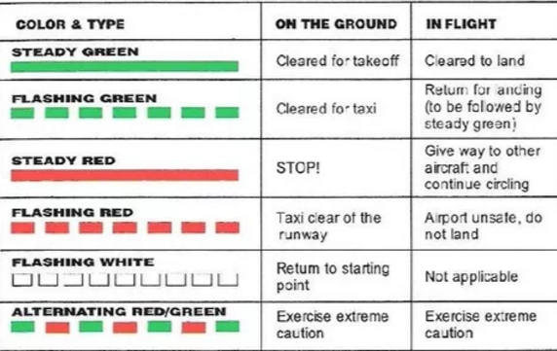
  Tach | For each engine
  Oil Temp | For each engine
  Manifold Pressure | Const. Sp. Prop
  Airspeed Indicator
  Anti-Collision Lights
  Oil Pressure | For each engine
  Fuel Gage | For each tank
  Altimeter
  Magnetic Compass
  ELT
  Seatbelts
  Stall Horn
  Fuses within Reach
  Landing Light | If for hire
  Beacon or Strobe
  Position Lights
  Source of Power
  Alternator / Source of Power
  Radios
  Attitude Indicator
  Ball
  Clock
  Adjustable Sensitive Altimeter
  Rate of Turn Indicator
  Directional Gyro
  DME over FL240
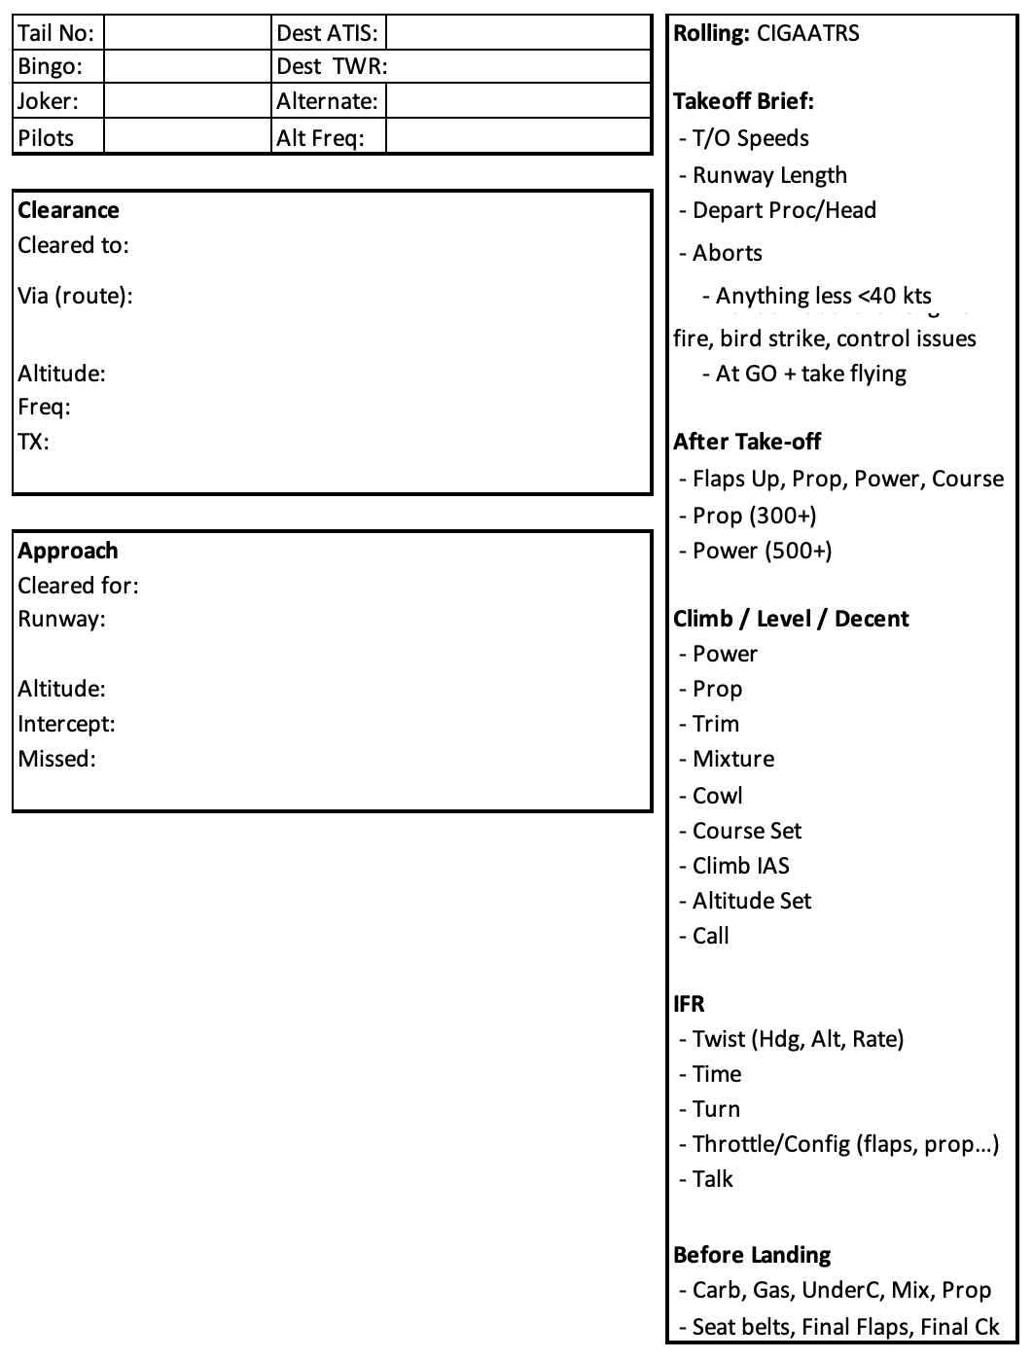

EMERGENCY PROCEDURES – CESSNA 180K
ENGINE FAILURE DURING CRUISE  - Best Glide  - Find Landing Site  - Carb Heat – ON  - Primer – IN & LOCKED  - Fuel Selector – BOTH  - Mixture – RICH  - Mags – ON OR START  - DECLARE EMERGENCY – Current Freq. or 121.5  - Transponder 7700  BEST GLIDE (FLAPS UP)  2800 lbs – 75 KTS  2400 lbs – 70 KTS  2000 lbs – 65 KTS  EMERGENCY LANDING – NO POWER  - Airspeed – 75 KTS (flaps UP)  65 KTS (flaps DOWN)  - DECLARE EMERGENCY  - Seat Belts – SECURE  - Mixture – IDLE CUTOFF  - Fuel Selector – OFF  - Mags – OFF  - Transponder – 7700  - All Switches (Except Master) – OFF  - Wing Flaps – AS REQUIRED  - Master – OFF  - Doors – UNLATCHED  - Touchdown – TAIL LOW  - FLY IT ‘TIL IT’S STOPPED!  LOST COMMUNICATION – SQUAK 7600  VFR – Remain VFR, Land, Light Signals  IFR  Remain on route assigned, expected or direct to the fix if vectored in the last ATC clearance, or fly the route as filed in the flight plan.  Remain at highest altitude assigned in clearance, or higher MEA. At clearance limit, begin descent & approach at filed or EFC time. | ENGINE FAILURE AFTER TAKEOFF  - Best Glide  - Mixture – Cut OFF  - Fuel – OFF  - Mags – OFF  - Flaps – As Req’d  - Falps DOWN @ 65 KTS  - Doors – UNLATCHED  - DECLARE EMERGENCY  - Master – OFF  ENGINE FIRE  - Mixture – IDLE CUTOFF  - Fuel –OFF  - Cabin HEAT/AIR – OFF  - Overhead Vents – OPEN  - Lower Nose to put out fire  - BEST GLIDE  - DECLARE EMERGENCY – Current Freq. or 121.5  - Master OFF  - Prepare for LANDING  LOW VOLTAGE LGIHT ILLUMINATES DURING FLIGHT OR AMMETER INDICATES DISCHARGE  - Avionics Power Switch – OFF  - Alternator Circuit Breaker – CHECK IN  - Master Switch – OFF (both sides)  - Master Switch – ON  - Low Voltage Light – CHECK OFF  - Avionics Power Switch – ON  If low voltage illuminates again…  - Alternator – OFF  - Non-req’d Radio and Elec – OFF  - Flight – TERMINATE when able  AMMETER SHOWS EXCESSIVE CHARGE  - Master Switch Alternator Side – OFF  - Alternator Circuit Breaker – PULL  - Electrical Equipment – OFF  - Flight – TERMINATE when able

